

ASSIGNMENT

**CSE2011 – DATA STRUCTURES AND ALGORITHMS**



**(B.Tech. CSE Specialisation in Bioinformatics)**

**WINTER SEMESTER 2020-2021**

|  |  |
| --- | --- |
| **Name:** | ALOK MATHUR |
| **Reg. No:** | 20BCB0086 |
| **Slot:** | A1 |
| **Faculty Name:** | SRIVANI A Ma’am |

**VIT – A Place to Learn; A Chance to Grow**

**1.Applications of Stacks and Queues**

**Stack using queues**:

Explain in details how a stack can be implemented using two queues along with its algorithm and diagrams

**Queue using stacks**:

Explain in details how a queue can be implemented using two stacks along with its algorithm and diagrams

Answer

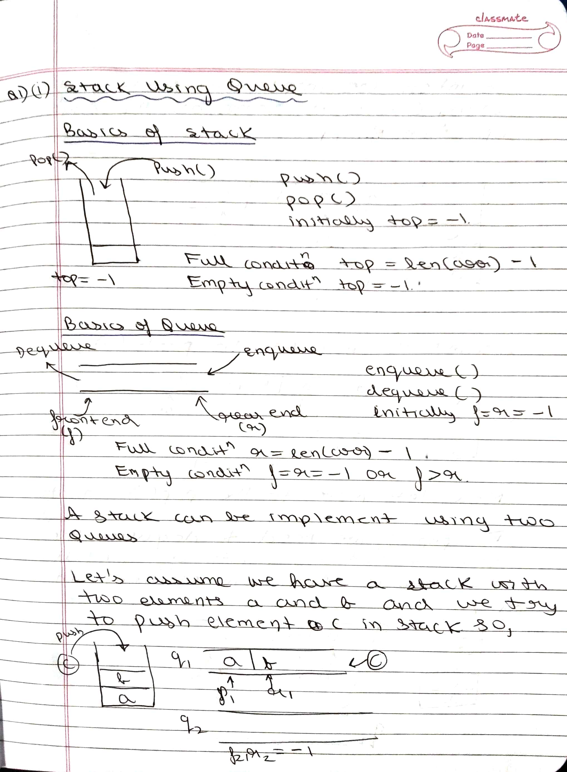

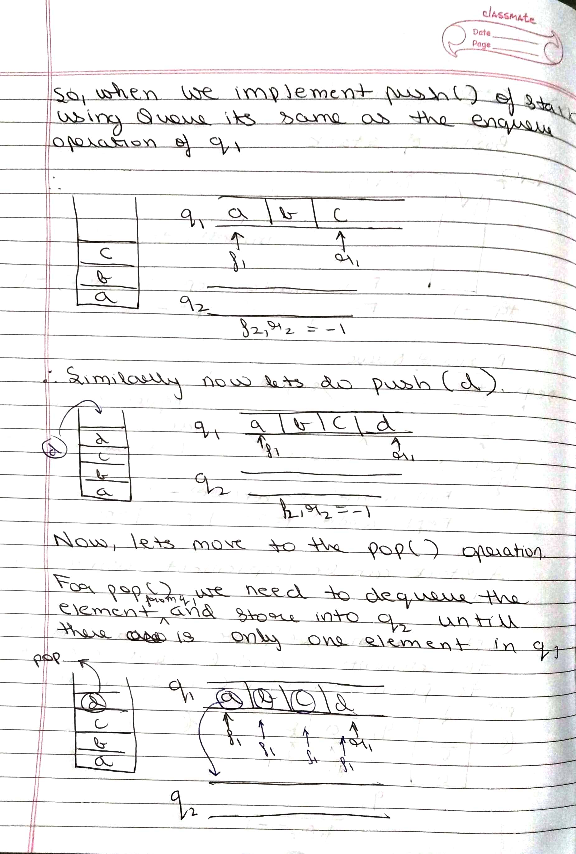

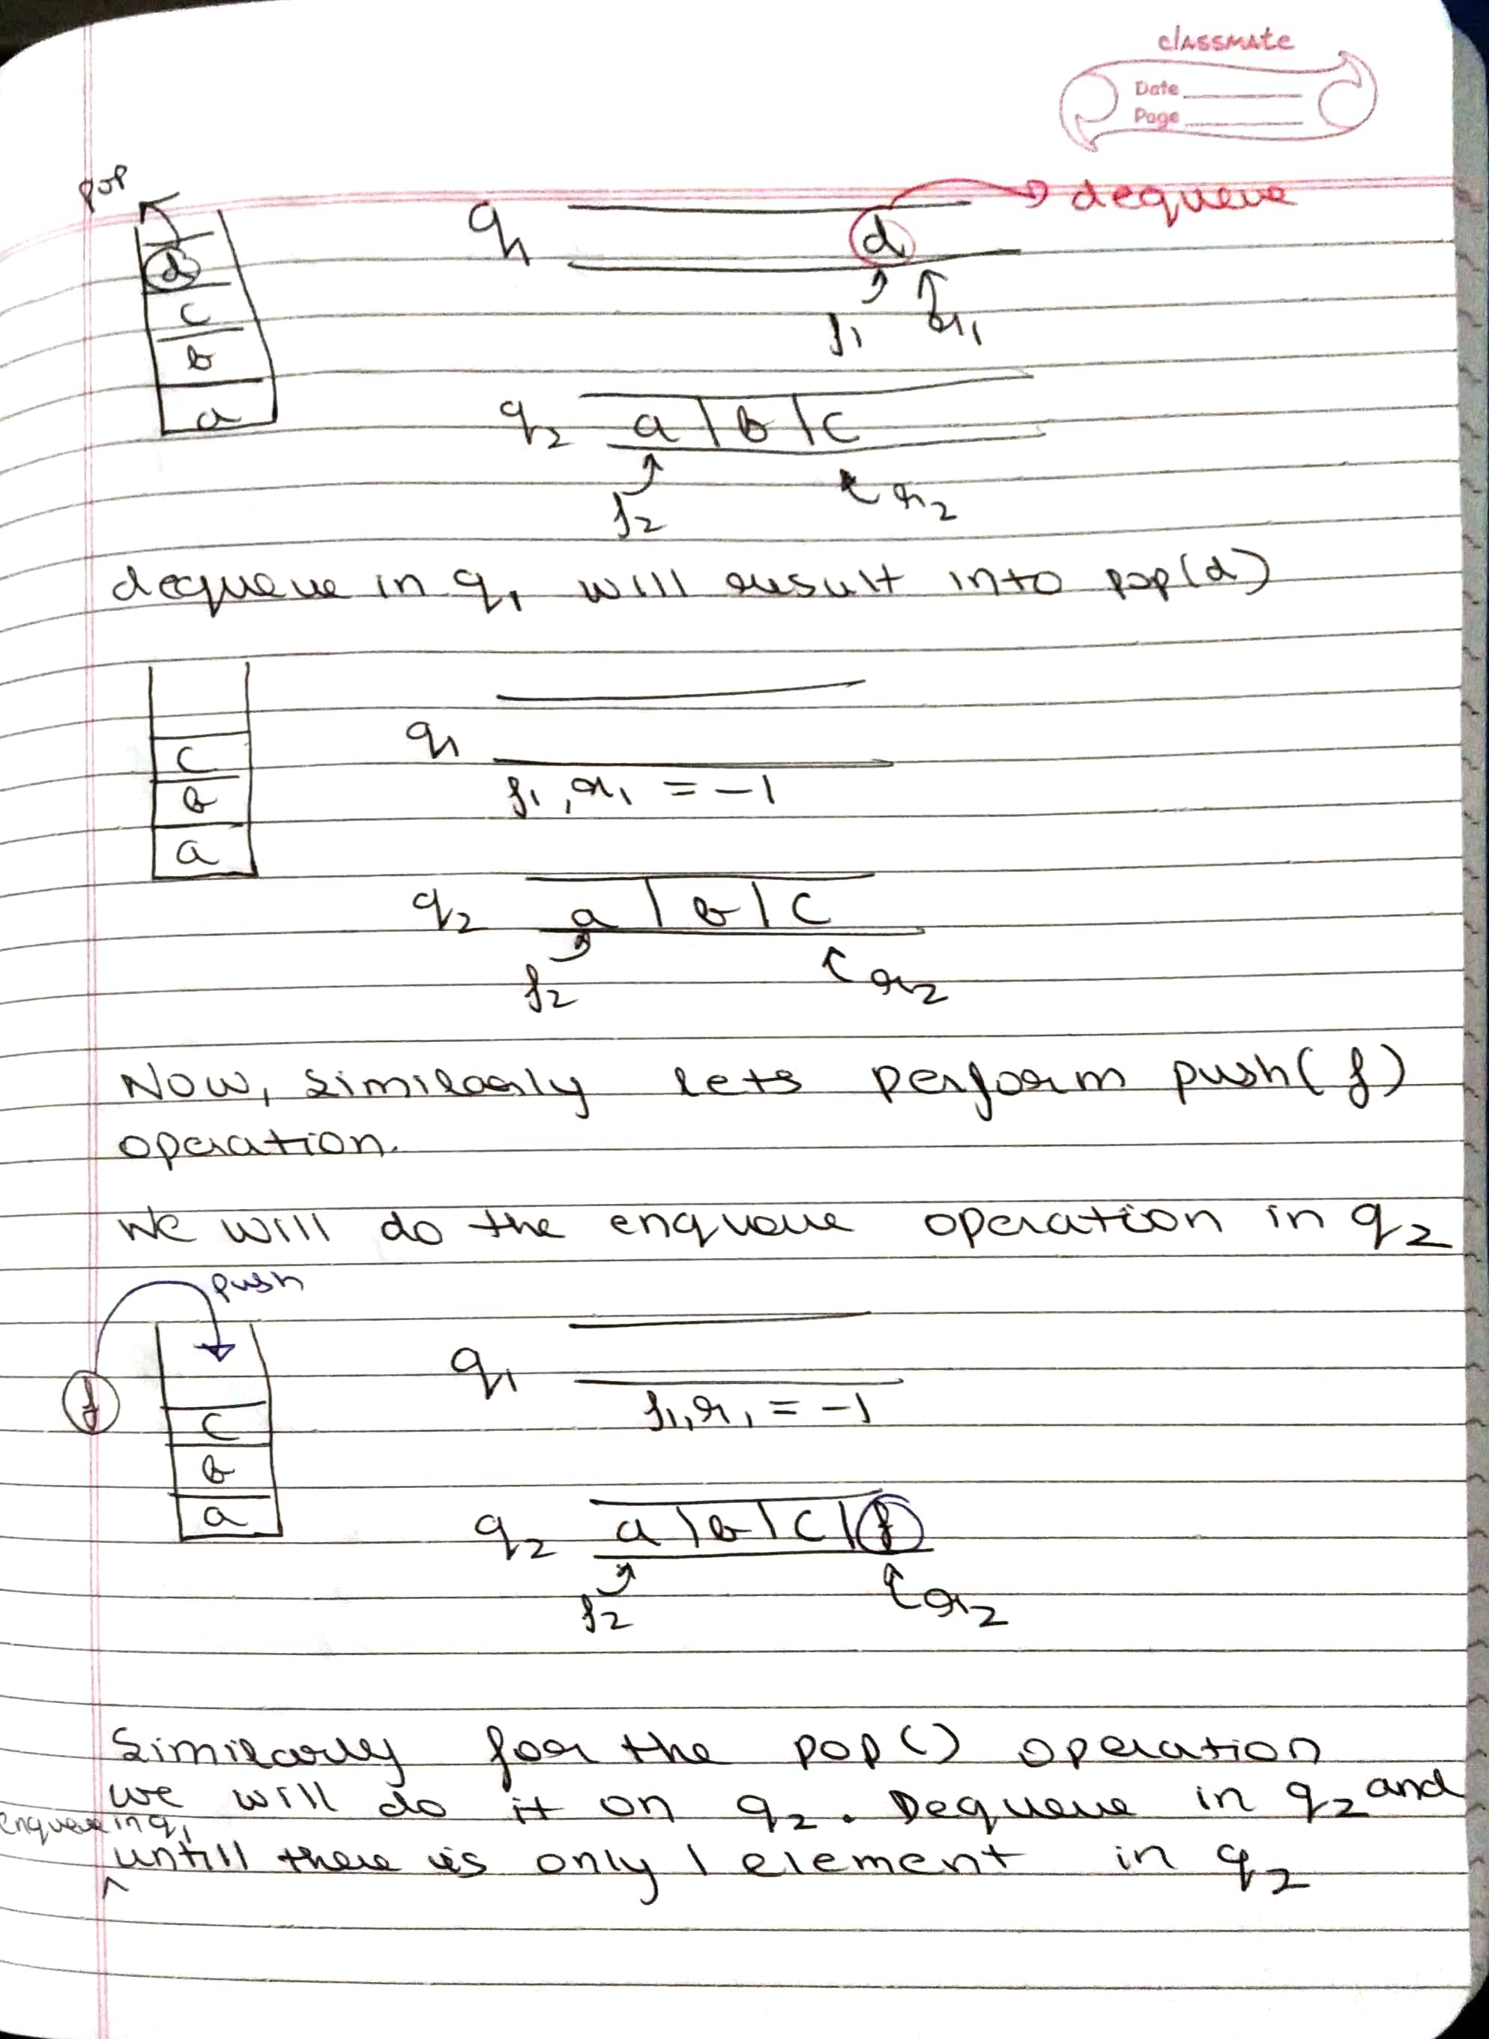

**Algorithm**

**Push Algorithm**

**The following are the steps to perform the push operation:**

**Step 1:** Consider two queues, i.e., Q1 and Q2, and the element to be inserted in the queue is x.

**Step 2:** element= Q1.enqueue(x);

**Step 3:** return element;

**Pop Algorithm**

**The following are the steps to delete an element from the queue:**

**Step 1:** Consider two queues, i.e., Q1 and Q2, and we want to remove an element from the queue.

**Step 2:** if  !Q1.isEmpty() then

             size:= Q1.size();

             for i=0…size-1 do

             Q2.enqueue(Q1.dequeue());

             end

             int item = Q1.dequeue();

             for j=0…size-1 do

             Q1.enqueue(Q2.dequeue());

             end

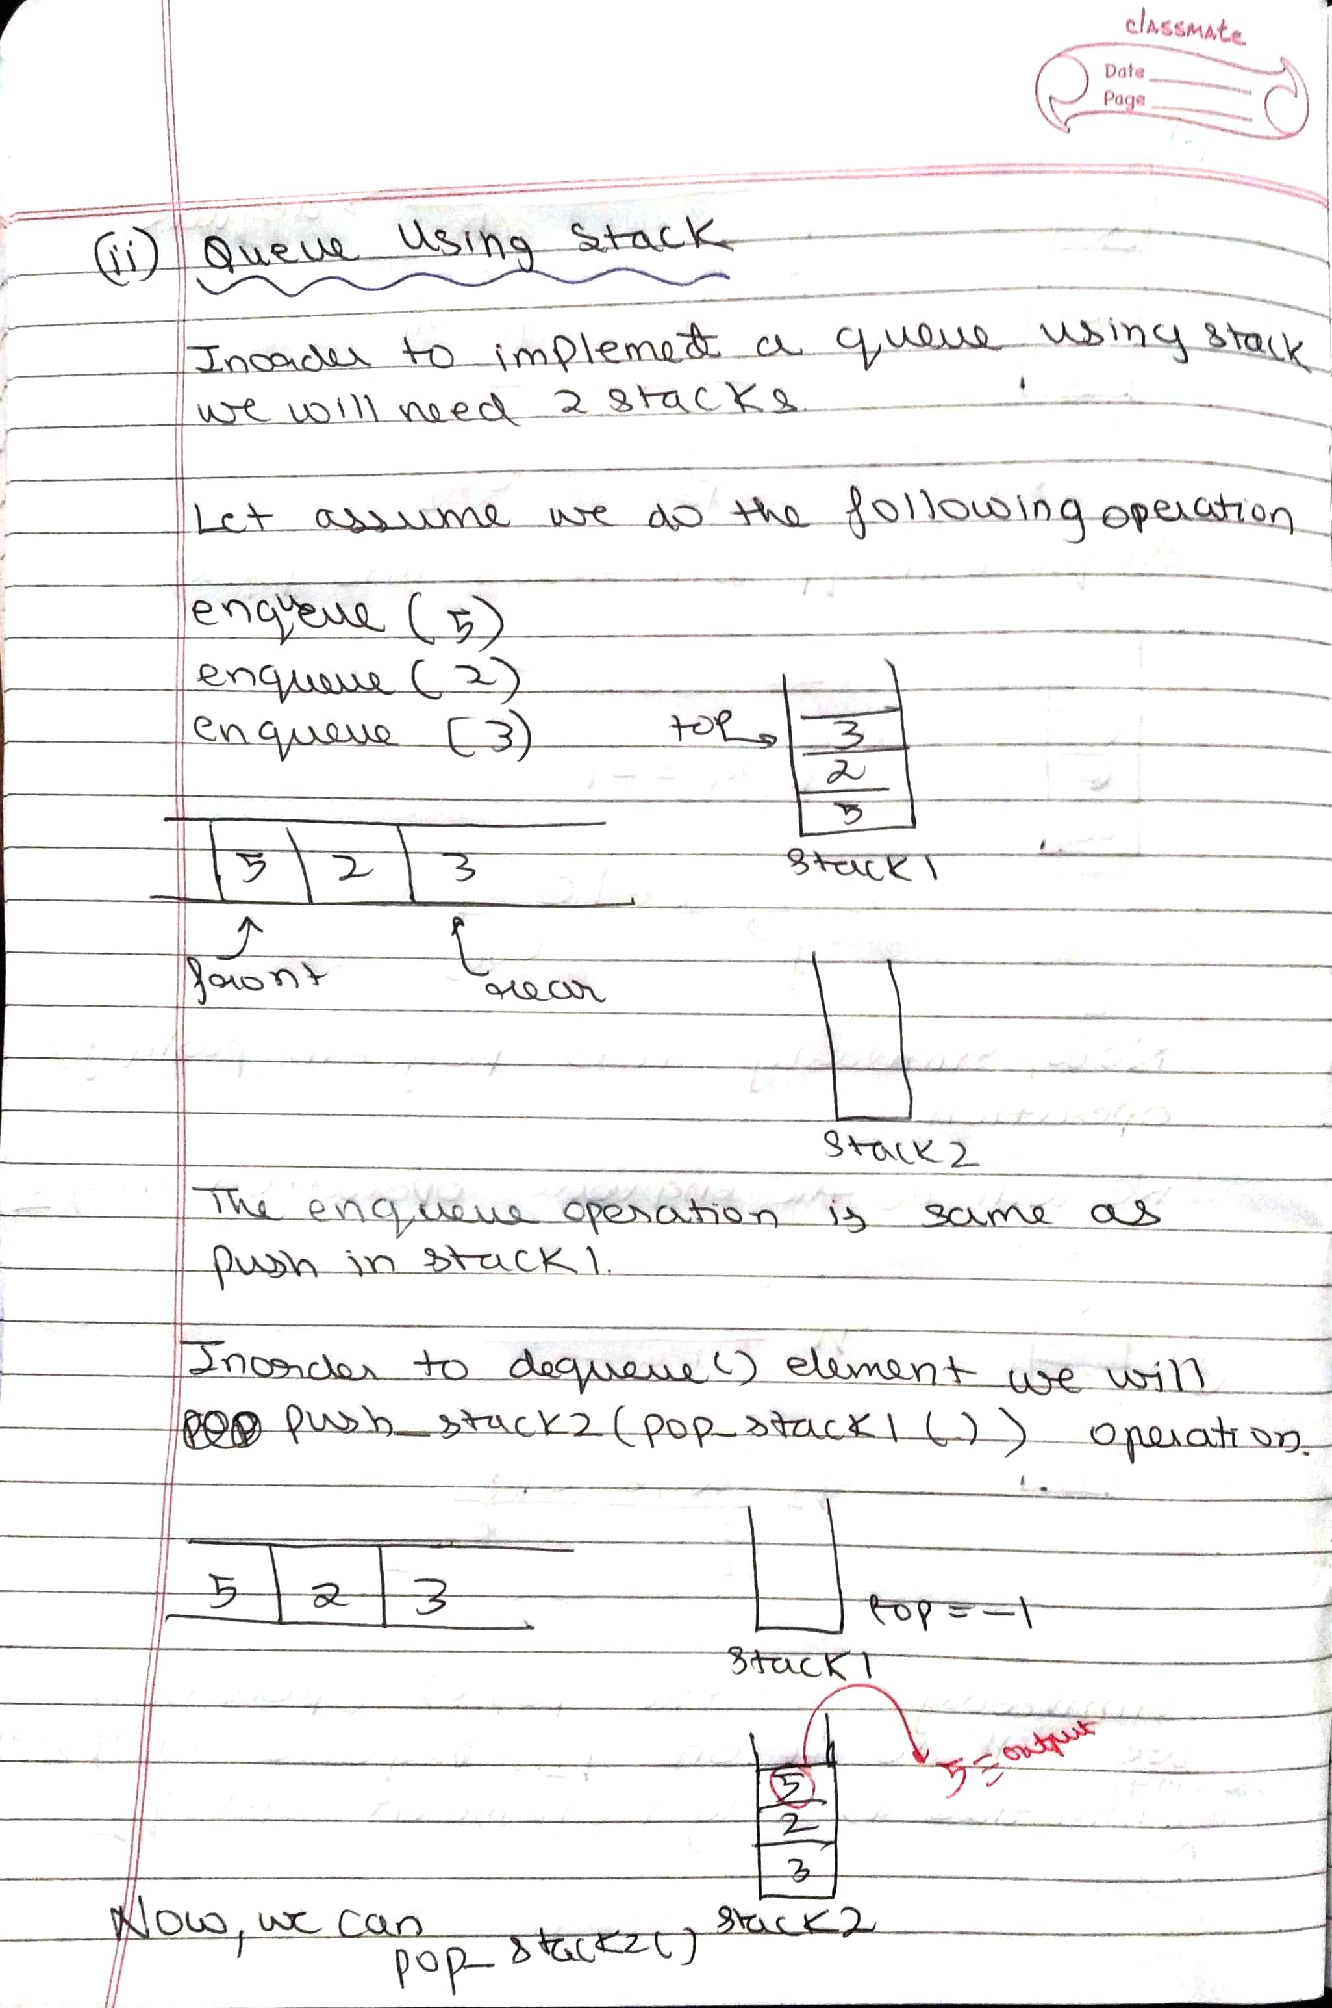

**Algorithm**

Enqueue

Step 1: Take two stacks S1 and S2.

Step 2: Push everything to S1 taking into consideration that S1 has unlimited size.

Dequeue

Step 1: If both S1 and S2 is empty return -1.

Step 2: Push everything to S2 from S1.

Step 3: Delete(pop) the top element from S2.

**2. Operations on Binary Tree**

i) For a binary tree what will be the result of the following. Give examples

for each with neat diagrams

Left View of the tree

Right View

Top View

Bottom View

Mirror Image

Answer

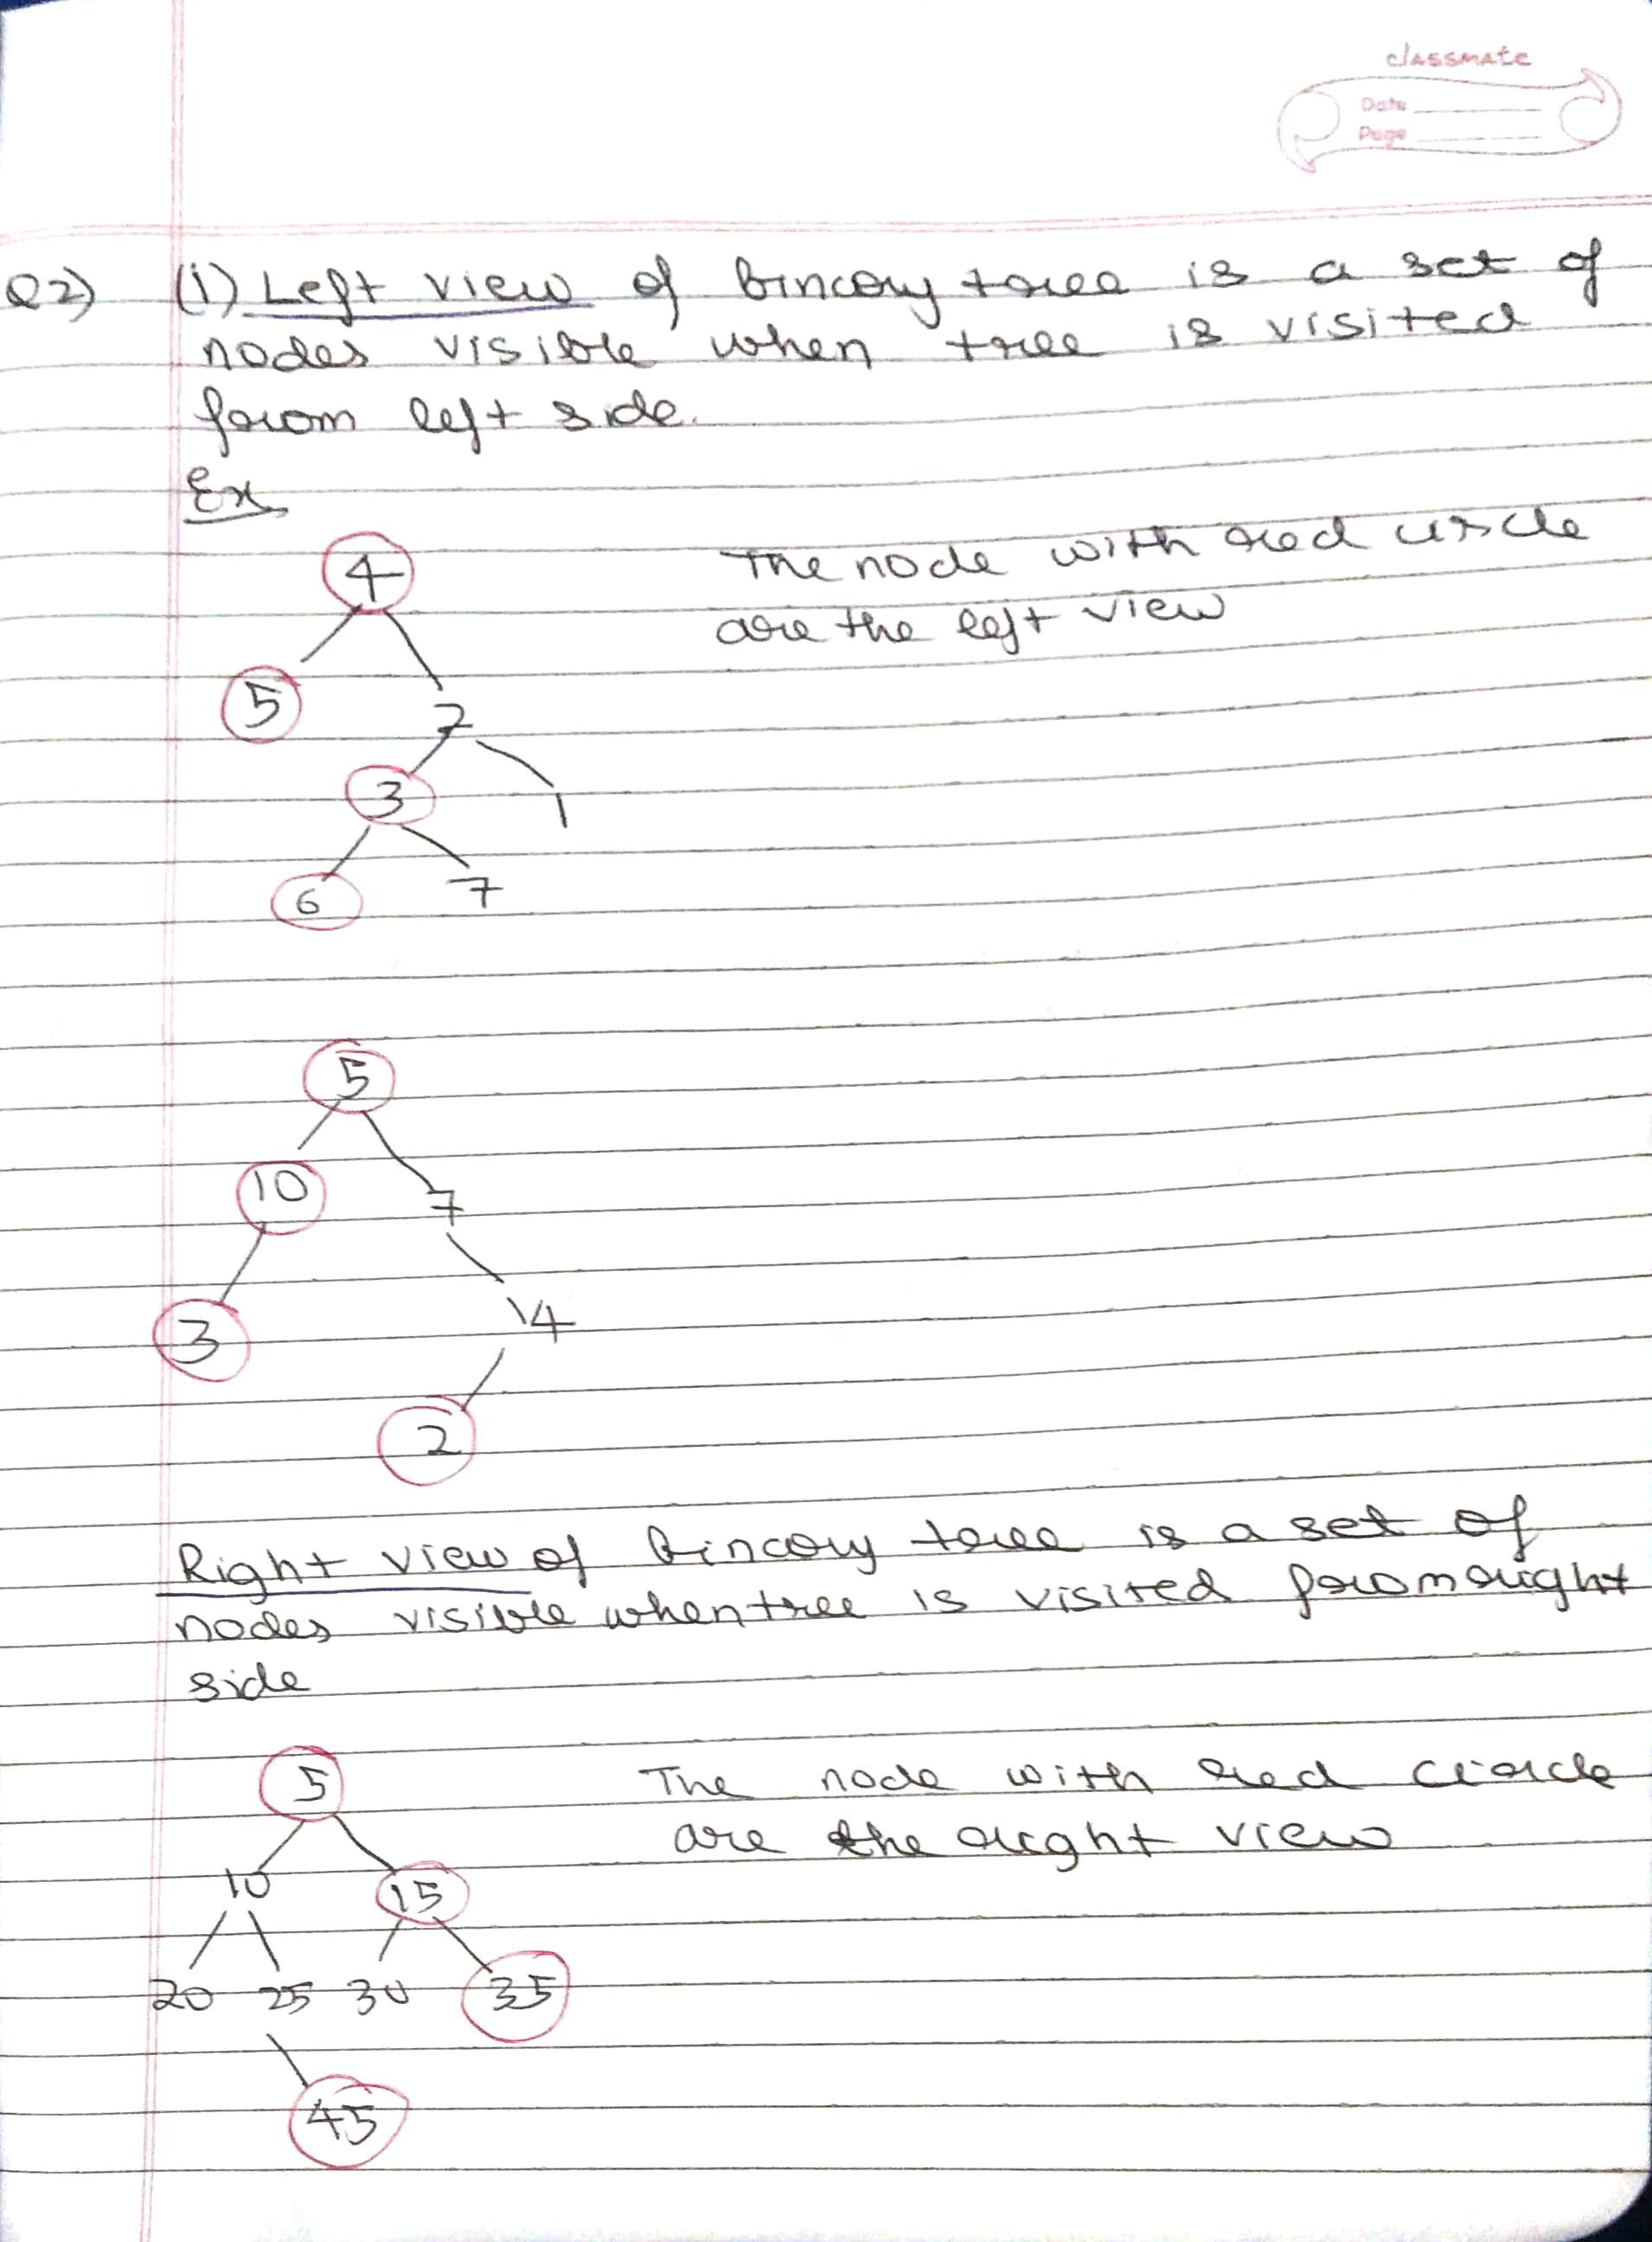

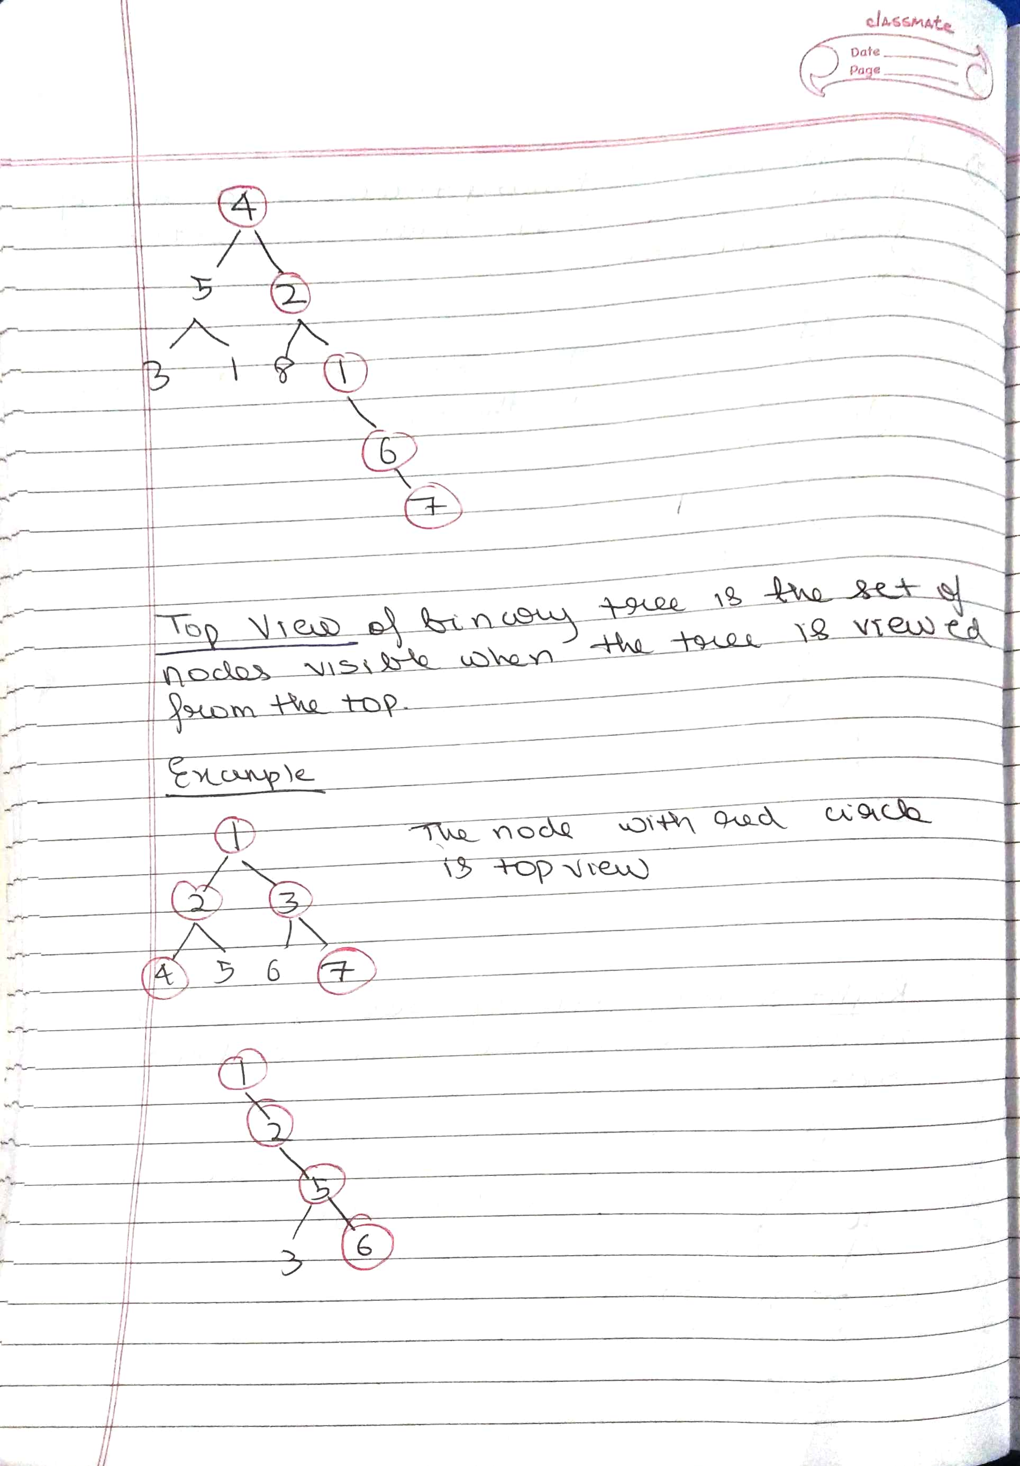

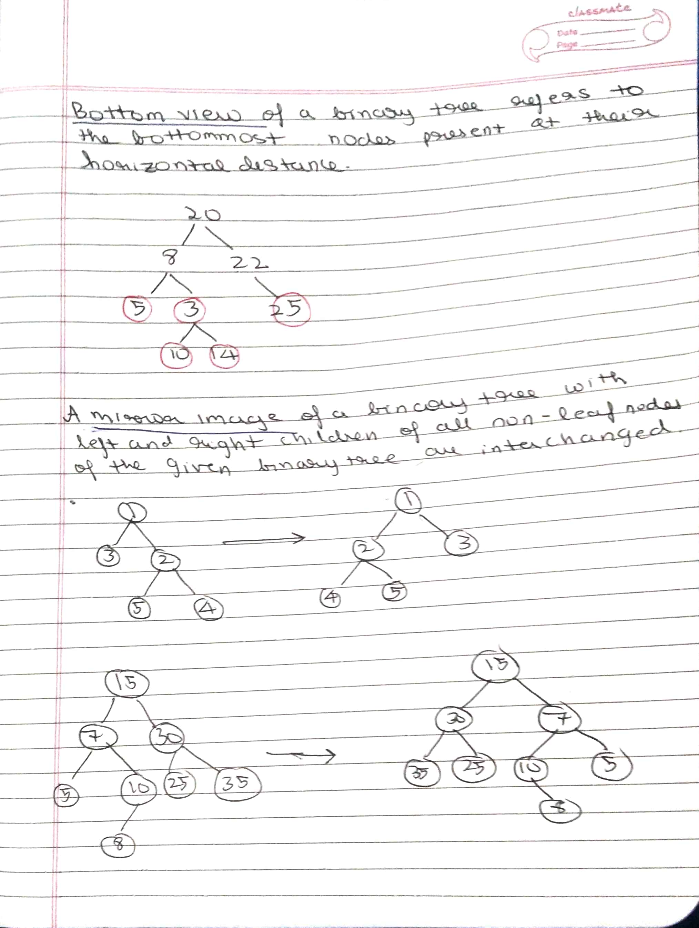

3. One real life application (not in course content) of any one of the data structures given in the course syllabus.

Answer

**Real life examples of stack are:**

* To ***reverse a word***. You push a given word to stack - letter by letter - and then pop letters from the stack.
* An ***"undo"*** mechanism in text editors; this operation is accomplished by keeping all text changes in a stack.
  + *Undo/Redo*stacks in Excel or Word.
* ***Language processing*** :
  + *space for parameters and local variables* is created internally using a stack.
  + compiler's*syntax check for matching braces* is implemented by using stack.
* A ***stack of plates/books*** in a cupboard.
* Wearing/Removing ***Bangles***.
* Expression evaluation and syntax parsing, many virtual machines like JVM are stack oriented.
* Support for***recursion***
  + Activation*records of method calls.*

Reverse A Word Using Stack Process :-

1. Create an empty stack.
2. Traverse the entire string, while traversing add the characters of the string into a temporary   
   variable until you get a space(‘ ‘) and push that temporary variable into the stack.
3. Repeat the above step until the end of the string.
4. Pop the words from the stack until the stack is not empty which will be in reverse order.